

# **Unify Fashion Shop**

Design Document

|  |  |  |  |
| --- | --- | --- | --- |
| **Faculty:** | NGÔ PHƯỚC NGUYÊN | |  |
| **Batch No:** | F2-13-1404-S0 | |  |
| **Group No:** | 01 | |  |
| **Students:** |  | **Fullname** | **Roll No.** |
|  | 1. | TRẦN HỮU QUANG | Student806329 |
|  | 2. | NGUYỄN NGỌC CHẤN | Student806304 |
|  | 3. | NGUYỄN THIỆN THUẬT | Student806538 |
|  | 4. | ĐÀM TRỌNG SANG | Student753748 |

Table of Contents

Table of contents 2

**Review 1** 3

* 1. Introduction 4
  2. Existing Scenario 4
  3. Customer Requirement Specification 4
  4. Functional Requirement Specification 5
  5. System Requirements 9
  6. Development Software 9
  7. Technology 9

**Review 2** 10

* 1. Table Definition 11
  2. Database Relationship Diagram 19

**Review 3** 42

* 1. Site map 43
  2. GUI Design 45

**Task sheet** 58

**Acknowledgements**

The satisfaction that accompanies that the successful completion of any task would be incomplete without the mention of people whose ceaseless cooperation made it possible, whose constant guidance and encouragement crown all efforts with success.

We are grateful to our project guide Mr. Ngo Phuoc Nguyen for the guidance, inspiration and constructive suggestions that helpful us in the preparation of this project.

We also thank our colleagues who have helped in successful completion of the project.

Group 01 _ F2-13-1404-S0

**REVIEW 1**

1. Problem Definition:
   1. Introduction:

Unify Shop is an online shopping application for Unify Company to help the company joins the modern trending online markets. The application will help the company connect to their consumer thought the internet.

* 1. Existing Scenario:

The company deals in buying and selling the clothes. The main products Unify selling are shirt, jean, belt and Shoes for man, women and kid.

But as the business is expanding day by day, the company has decided to reach to the people though web-site

1. Customer Requirements Specifications:

2.1 User:

* User will able searching for clothes and order it for the choice of their wills.
* User can review a product which they like and feedback what don’t like to admin.
* User can order online without purchase or register an account.
* The Order needs to purchase after the products be delivered.

2.2. Sale Person:

* Will check orders and delivered the orders.
* Can reply all the customer comment and feedbacks.
* Can see Report Selling of month, and Year.

1. Function Requirement Specification:
   1. Guest:

* Guest can register as User.
* Guest can login as User.
* Guest can make order products.
  1. User:
* User can update his/her profile.
* User can review his/her through about product by comment.
* User can edit his/her own comment.
* User can see what his/her ordered.
* User can send feedback to Admin.
* User can check their Order history.
* User able order product.
  1. Sale Person:
* Sale person can see all undelivered order.
* Sale person can confirm order is delivered.
* Sale person can see the selling report in a day, or a month, or a year.
* Sale person can reply user feedbacks.
* Sale person can insert new Product.
* Sale person can edit a product.
* Sale person can set a product for sale or not.
* Sale person can see detail of a product.
* Sale person can reply comment of user.
* Sale person can see profile of a user.
* Sale person can see new register User of a day, or month or a year.
* Sale person can edit their own profile.
* Sale person can edit homepage content.
  1. Administrator:
* Administrator can see all undelivered order.
* Administrator can confirm order is delivered.
* Administrator can add new User or a new Sale Person.
* Administrator can ban a User or a Sale Person.
* Administrator can delete a comment.
* Administrator can reply to a user comment.
* Administrator Only can edit his/her own comment.
* Administrator can reply a feedback.
* Administrator can see new register User of a day, or month or a year.
* Administrator can see the selling report in a day, or a month, or a year.
* Administrator can see a detail of a product.
* Administrator can insert new Product.
* Administrator can edit a product.
* Administrator can set a product for sale or not for sale.
* Administrator can edit the homepage content.

1. System Requirement:
2. **Hardware Requirements:**
   * AMD Opteron, AMD Athlon 64, Intel Xeon with Intel EM64T support, Intel Pentium IV with EM64T support
   * Processor Speed minimum 1.4 hz
   * 1G of RAM or higher. ( 4 GB **Recommended** )
   * Hard disk requirement : minimum 50GB
   * Windows 7 ultimate, or window server 2008 R2 or higher
3. **Software Requirements:**
   * SQL Server 2012 x64 bit
   * Netbean 8.0 or higher
   * JavaEE 7 SDK
   * Java Development Kit (JDK) 1.7u89 or higher ( Recommended jdk 1.8)
   * Glassfish Server 4.1
   * Type 4-2.0 JDBC driver for SQL Server 2012 RC4
   * Internet Explorer 10 or higher

## Task Sheet 1

|  |  |  |  |  |  |
| --- | --- | --- | --- | --- | --- |
| **Project Ref. No.** | | **Project Name:**  **Unify Fashion Shop** | **Date of Preparation of Activity Plan** | | |
| No. | Task | Description | Start  Date | Complete  Date | Team member |
| 01 | **Review 1** | Problem statement | **20 / 11 / 2015** | **30 / 11 / 2015** |  |
| 02 | Function requirement specification |

**Signature of Team leader** **Signature of Instructor**

**REVIEW 2**

* 1. 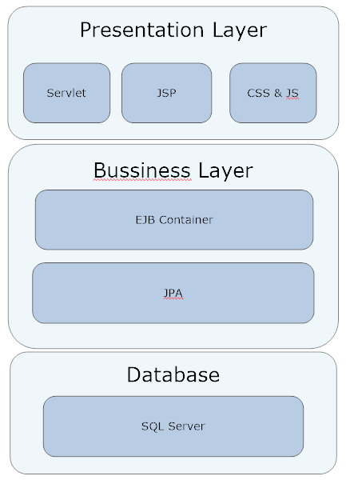Architecture and the design of the project:

1. User Case and Sequence Diagram:

## Guest:

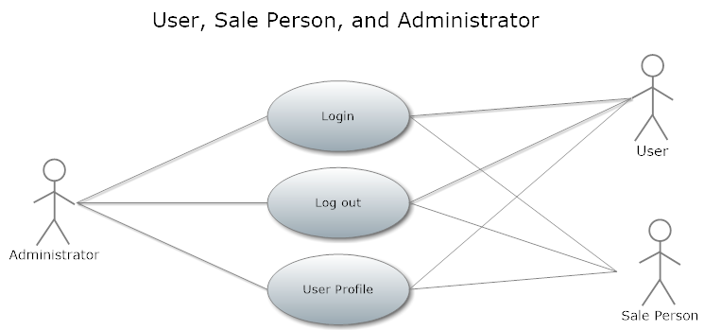

### **Login:**

|  |  |  |
| --- | --- | --- |
| **Author** | Tran Huu Quang | |
| **Use Case Name** | Login | |
| **Actors** | Guest | |
| **Description** | Guest login as User, or Sale Person, or Administrator | |
| **Requirements** | Actor provides email and password | |
| **Pre-conditions** |  | |
| **Post-conditions** | Success: User logged in to website.  Fail: Refill information | |
| **Basic flow** | Actor Actions:  1. Actor go to Home page of website.  3. Actor inputs Email and Password, then click the Sign In button. | System Responses:  2. System redirects to Home page and displays Login form on the left with the following control:  - ‘Email’ text field  - ‘Password’ text field  - ‘Sign in’ button  4. System checks the information  [Exception 1]  5. System redirects to Actor’s Home page. |
| **Alternative flow** | Actor Actions:  [Alternative 2]  1. Actor click ‘OK’ button, inputs Email and Password, then click the Login button.  [Alternative 1]  1. Actor click ‘Back to Home’ button. | System Responses:  2. System checks the information  [Exception 1]  3. System redirects to Actor’s Home page.  2. System returns to Home page. |
| **Exception** | Actor Actions:  [Exception 1]  1. Actor input invalid username and password. | System Responses:  - System redirect to Login page with the following controls:  - ‘Email’ text field  - ‘Password’ text field  - ‘Sign In’ button.  - ‘Back to Home’ button.  System show a message box: “Invalid Email and password”.[Alternative 2] |

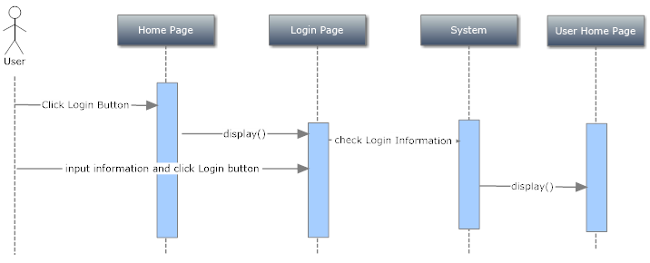

### **Logout:**

|  |  |  |
| --- | --- | --- |
| **Author** | Tran Huu Quang | |
| **Use Case Name** | Login | |
| **Actors** | User, Sale Person and Admin | |
| **Description** | User, Sale Person and Admin wants to log out of the System. | |
| **Requirements** |  | |
| **Pre-conditions** | Actor has logged in. | |
| **Post-conditions** | Success: Actor Logged out. | |
| **Basic flow** | Actor Actions:  1. Actor clicks ‘Log out’ button on the Actor’s Home menu. | System Responses:  2. System redirect to Logout page, remove session, and then redirect to Login page. |
| **Alternative flow** |  |  |
| **Exception** |  |  |

### ***Update Profile*:**

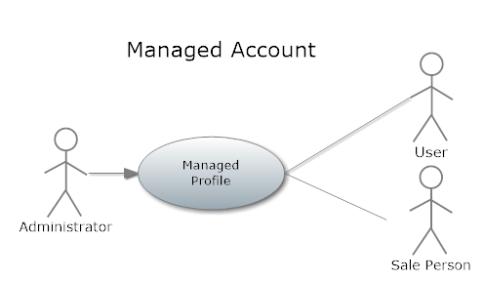

|  |  |  |
| --- | --- | --- |
| **Author** | Tran Huu Quang | |
| **Use Case Name** | Update Profile | |
| **Actors** | User, Sale Person and Admin | |
| **Description** | User, Sale Person and Admin wants to Update his/her profile’s information. | |
| **Requirements** | Actor provides profile information | |
| **Pre-conditions** | Actor has logged in. | |
| **Post-conditions** | Success: Profile’s information of this user has been updated.  Fail: Refill information | |
| **Basic flow** | Actor Actions:  1. Actor clicks ‘Profile’ button in Actor’s Home page menu.  3. Actor updates information and click ‘Save’ button. [Alternative 1] | System Responses:  2. System redirects to Update Profile page and displays Update Profile form with the following control :  - ‘Email’ text field (read only)  - ‘Old Password’ text field  - ‘New Password’ text field  - ‘New Password Confirm’ text field  - ‘First Name’ text field  - ‘Last Name’ text field  - ‘Birthday’ text field  - ‘Gender’ checkbox group  - ‘Address’ text field  - ‘Phone’ text field  - ‘Save’ button  - ‘Back to Home’ button  4. System checks the information  [Exception 1]  5. System update the account into database and then redirects to Actor Home page. |
| **Alternative flow** | Actor Actions:  [Alternative 1]  1. Actor click ‘Back to Home’ button. | System Responses:  2. System returns to Home page. |
| **Exception** | Actor Actions:  [Exception 1]  1. Actor lefts ‘New Password’ text field blank.  2. Actor lefts ‘New Confirm Password’ text field blank.  3. New Password and New Password Confirm don’t match.  4. Actor lefts ‘First Name’ text field blank.  5. Actor lefts ‘Birthday’ datebox blank.  6. Input age to ‘Birthday’ datebox less than 16.  7. Actor lefts ‘Address’ text field blank.  8. Actor lefts ‘Phone’ text field blank.  9. Input phone not in numeric or phone length not in range 8 – 14 character. | System Responses:  System displays message to Actor :  - ‘Password cannot be blank’’.  - ‘Confirm Password can’t be blank’.  - ‘Confirm password not match Password.’  - ‘First Name cannot be blank’.  - ‘Last Name cannot be blank’.  - ‘Birthday is invalid’.  - ‘Age must over 16’.  - ‘Address cannot be blank’.  - ‘Phone is invalid’.  - ‘The phone number should be numeric only and must be between 8 and 14 digits’. |

### **Register Account as User:**

|  |  |  |
| --- | --- | --- |
| 1. **Author** | Tran Huu Quang | |
| **Use Case Name** | Register as User | |
| **Actors** | Guest | |
| **Description** | Guest wants to register with the website to become a Seller member. | |
| **Requirements** | Guest provides Guest’s information | |
| **Pre-conditions** |  | |
| **Post-conditions** | Success: Guest creates a Buyer account in this website  Fail: Refill information | |
| **Basic flow** | Actor Actions:  1. Actor clicks ‘Register’ link in Home page  5. Actor inputs register’s information, select ‘Seller’ radio button and click ‘Register’ button. [Alternative 1] | System Responses:  2. System redirects to Register page and displays Registration form with the following control :  - ‘Email’ text field  - ‘Password’ text field  - ‘Confirm Password’ text field  - ‘First Name’ text field  -‘Last Name’ text field  - ‘Birthday’ datebox  - ‘Gender’ checkbox group  - ‘Address’ text field  - ‘Phone’ text field  - ‘Register’ button  - ‘Back to Home’ button  6. System checks the information  [Exception 1]  7. System inserts the account into database, show message: ‘Your account has been created!’ and then redirects to Login page. |
| **Alternative flow** | Actor Actions:  [Alternative 1]  1. Actor click ‘Back to Home’ button. | System Responses:  2. System returns to Home page. |
| **Exception** | Actor Actions:  [Exception 1]  1. Actor lefts ‘Email’ text field blank or input an invalid email address.  2. Email has already exists.  3. Actor lefts ‘Password’ text field blank.  4. Actor lefts ‘Confirm Password’ text field blank.  5. Password and confirm password don’t match.  6. Actor lefts ‘First Name’ text field blank.  7. Actor lefts ‘Last Name’ text field blank;  8. Actor lefts ‘Birthday’ datebox blank.  9. Input age to ‘Birthday’ datebox less than 16.  10. Actor lefts ‘Address’ text field blank.  11. Actor lefts ‘Phone’ text field blank.  112 Input phone not in numeric or phone length not in range 8 – 14 character. | System Responses:  System displays message to Actor :  - ‘Email is invalid’.  - ‘This Email has already exist!’.  - ‘Password cannot be blank’’.  - ‘Confirm Password can’t be blank’.  - ‘Confirm password not match password.’  - ‘First Name cannot be blank’.  - ‘Last Name cannot be blank’.  - ‘Birthday is invalid’.  - ‘Age must over 16’.  - ‘Address cannot be blank’.  - ‘Phone is invalid’.  - ‘The phone number should be numeric only and must be between 8 and 14 digits’. |

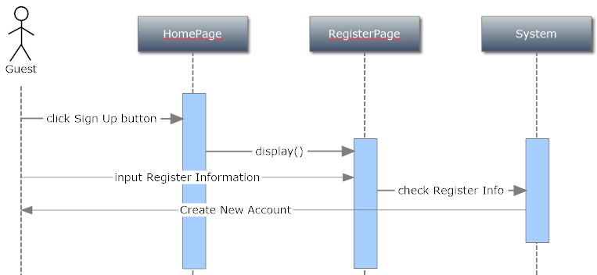

### **Add New Sale Person:**

|  |  |  |
| --- | --- | --- |
| 1. **Author** | Tran Huu Quang | |
| **Use Case Name** | Add New Sale Person | |
| **Actors** | Administrator | |
| **Description** | Add New Sale person member. | |
| **Requirements** | Admin provides Sale Person’s information | |
| **Pre-conditions** |  | |
| **Post-conditions** | Success: Guest creates a Buyer account in this website  Fail: Refill information | |
| **Basic flow** | Actor Actions:  1. Actor clicks ‘Register’ link in Home page  5. Actor inputs register’s information, select ‘Seller’ radio button and click ‘Register’ button. [Alternative 1] | System Responses:  2. System redirects to Register page and displays Registration form with the following control :  - ‘Email’ text field  - ‘Password’ text field  - ‘Confirm Password’ text field  - ‘First Name’ text field  -‘Last Name’ text field  - ‘Birthday’ datebox  - ‘Gender’ checkbox group  - ‘Address’ text field  - ‘Phone’ text field  - ‘Register’ button  - ‘Back to Home’ button  6. System checks the information  [Exception 1]  7. System inserts the account into database, show message: ‘Your account has been created!’ and then redirects to Login page. |
| **Alternative flow** | Actor Actions:  [Alternative 1]  1. Actor click ‘Back to Home’ button. | System Responses:  2. System returns to Home page. |
| **Exception** | Actor Actions:  [Exception 1]  1. Actor lefts ‘Email’ text field blank or input an invalid email address.  2. Email has already exists.  3. Actor lefts ‘Password’ text field blank.  4. Actor lefts ‘Confirm Password’ text field blank.  5. Password and confirm password don’t match.  6. Actor lefts ‘First Name’ text field blank.  7. Actor lefts ‘Last Name’ text field blank;  8. Actor lefts ‘Birthday’ datebox blank.  9. Input age to ‘Birthday’ datebox less than 16.  10. Actor lefts ‘Address’ text field blank.  11. Actor lefts ‘Phone’ text field blank.  112 Input phone not in numeric or phone length not in range 8 – 14 character. | System Responses:  System displays message to Actor :  - ‘Email is invalid’.  - ‘This Email has already exist!’.  - ‘Password cannot be blank’’.  - ‘Confirm Password can’t be blank’.  - ‘Confirm password not match password.’  - ‘First Name cannot be blank’.  - ‘Last Name cannot be blank’.  - ‘Birthday is invalid’.  - ‘Age must over 16’.  - ‘Address cannot be blank’.  - ‘Phone is invalid’.  - ‘The phone number should be numeric only and must be between 8 and 14 digits’. |

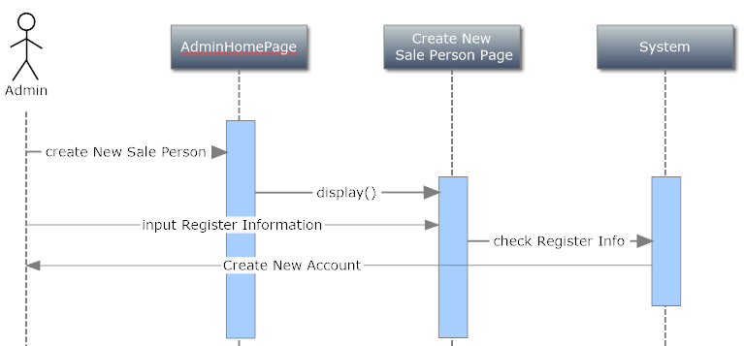

### **Insert New Product:**

|  |  |  |
| --- | --- | --- |
| **Author** | Nguyen Thien Thuat | |
| **Use Case Name** | Insert new Product | |
| **Actors** | Administrator, Sale Person | |
| **Description** | Sale Person or Administrator add new product. | |
| **Requirements** | Admin or Sale person provide Product Infomation | |
| **Pre-conditions** |  | |
| **Post-conditions** | Success: Create new Product for website  Fail: Refill information | |
| **Basic flow** | Actor Actions:  1. Actor clicks ‘Add New Product’ link in Home page  5. Actor inputs product’s information. | System Responses:  2. System redirects to Register page and displays Registration form with the following control :  - ‘Name’ text field  - ‘UnitPrice’ text field  - ‘Gender’ Select box  - ‘Description’ text area  - ‘Gender’ checkbox group  - ‘Choose Image’ input file  - ‘Available’ Check box  - ‘Add’ button  6. System checks the information  [Exception 1]  7. System inserts the account into database, show message: ‘This product has been created!’ and then redirects to Create Page. |
| **Alternative flow** | Actor Actions:  [Alternative 1]  1. Actor click ‘Back to Home’ button. | System Responses:  2. System returns to Home page. |
| **Exception** | Actor Actions:  [Exception 1]  1. Actor lefts ‘Name’ text field blank or input an invalid Product Name.  2. Product has already exists. | System Responses:  System displays message to Actor :  - ‘Product Name is invalid’.  - ‘This Product has already exist!’. |



* + 1. **Update Product:**

|  |  |  |
| --- | --- | --- |
| **Author** | Nguyen Thien Thuat | |
| **Use Case Name** | Insert new Product | |
| **Actors** | Administrator, Sale Person | |
| **Description** | Sale Person or Administrator add new product. | |
| **Requirements** | Admin or Sale person provide Product Infomation | |
| **Pre-conditions** |  | |
| **Post-conditions** | Success: Create new Product for website  Fail: Refill information | |
| **Basic flow** | Actor actions:  1. From ‘View List of Product’ page, actor clicks on to the ‘Product Name’ hyperlink which wants to modify.  3. Actor:   * Select Directory Category in ‘Directory Category’ combobox. [Alternative 1] * Inputs Directory Name into ‘Directory Name’ textfield. * Inputs Description into ‘Description’ textfield. * Inputs Directory Website into ‘Directory Website’ textfield. * Clicks on to ‘Browse’ button to select path of Directory Image, this path is displayed in ‘Directory Image Path’ textfield. * Clicks on to ‘Save’ button to finish adding. [Alternative 2] | System response:  2. System redirects to ‘Modify Directory’ page and display form with the following controls:  - ‘Name’ text field  - ‘UnitPrice’ text field  - ‘Gender’ Select box  - ‘Description’ text area  - ‘Gender’ checkbox group  - ‘Choose Image’ input file  - ‘Subcategory’ Select Box  - ‘Available’ Check box  - ‘Add’ button  4. System checks input information.  [Exception 1]  5. System updates information into the database.[Alternative 3] |
| **Alternative flow** | [Alternative 1]  1. Actor clicks on to ‘Other Directory Category’ button.  3. Actor inputs Directory Category Name into ‘Directory Category Name’ text field.  [Alternative 2]  1. Actor clicks on to ‘Back’ button.  [Alternative 3]  1. Actor has inputted Directory Category Name into ‘Directory Category Name’ text field. | 2. The ‘Directory Category Name’ text field appears.  2. System redirects to ‘View List of Directories’ page.  2. System updates Directory and adds new Directory Category into the database. |
| **Exception** | Actor Actions:  [Exception 1] | System Responses:  System displays message to Actor :  - ‘Product Name is invalid’. |



* + 1. **Add Category:**

|  |  |  |
| --- | --- | --- |
| **Author** | Nguyen Thien Thuat | |
| **Use Case Name** | Insert new Category | |
| **Actors** | Administrator, Sale Person | |
| **Description** | Sale Person or Administrator add new product. | |
| **Requirements** | Admin or Sale person provide Product Infomation | |
| **Pre-conditions** |  | |
| **Post-conditions** | Success: Create new Product for website  Fail: Refill information | |
| **Basic flow** | Actor Actions:  1. Actor clicks ‘Add New Product’ link in Home page  5. Actor inputs product’s information. | System Responses:  2. System redirects to Register page and displays Registration form with the following control :  - ‘Name’ text field  - ‘UnitPrice’ text field  - ‘Gender’ Select box  - ‘Description’ text area  - ‘Gender’ checkbox group  - ‘Choose Image’ input file  - ‘Available’ Check box  - ‘Add’ button  6. System checks the information  [Exception 1]  7. System inserts the account into database, show message: ‘This product has been created!’ and then redirects to Create Page. |
| **Alternative flow** | Actor Actions:  [Alternative 1]  1. Actor click ‘Back to Home’ button. | System Responses:  2. System returns to Home page. |
| **Exception** | Actor Actions:  [Exception 1]  1. Actor lefts ‘Name’ text field blank or input an invalid Product Name.  2. Product has already exists. | System Responses:  System displays message to Actor :  - ‘Product Name is invalid’.  - ‘This Product has already exist!’. |



* + 1. **Update Category:**

|  |  |  |
| --- | --- | --- |
| **Author** | Nguyen Thien Thuat | |
| **Use Case Name** | Insert new Product | |
| **Actors** | Administrator, Sale Person | |
| **Description** | Sale Person or Administrator add new product. | |
| **Requirements** | Admin or Sale person provide Product Infomation | |
| **Pre-conditions** |  | |
| **Post-conditions** | Success: Create new Product for website  Fail: Refill information | |
| **Basic flow** | Actor Actions:  1. Actor clicks ‘Add New Product’ link in Home page  5. Actor inputs product’s information. | System Responses:  2. System redirects to create Product page and displays Update Product form with the following control:  - ‘Name’ text field and read only  - ‘UnitPrice’ text field  - ‘Gender’ Select box  - ‘Description’ text area  - ‘Gender’ checkbox group  - ‘Choose Image’ input file  - ‘Available’ Check box  - ‘Add’ button  6. System checks the information  [Exception 1]  7. System inserts the account into database, show message: ‘This product has been updated!’ and then redirects to Page. |
| **Alternative flow** | Actor Actions:  [Alternative 1]  1. Actor click ‘Back to Home’ button. | System Responses:  2.System returns to Admin Home page. |
| **Exception** | Actor Actions:  [Exception 1]   1. Actor lefts ‘Name’ text field blank or input an invalid Product Name. 2. Actor lefts ‘UnitPrice’ text field blank or input an invalid UnitPrice. | System Responses:  System displays message to Actor:  - ‘Product Name is invalid’.  - ‘Unit Price is invalid’. |



* + 1. **Add Shopping Cart:**

|  |  |  |
| --- | --- | --- |
| **Author** | Nguyen Ngoc Chan | |
| **Use Case Name** | Add Shopping Cart | |
| **Actors** | User | |
| **Description** | User Create a shopping cart | |
| **Requirements** | Shopping cart must have Item | |
| **Pre-conditions** |  | |
| **Post-conditions** | Success: Created Order Successful waiting for admin to confirm delivered  Fail: Canceled the shopping cart | |
| **Basic flow** | Actor Actions:  1. Actor clicks ‘Shopping Cart’ link in Home page | System Responses:  2. System redirects to Shopping Cart page and displays the cart with the following control:  - List of Chosen control.  - ‘Name’ text field  - ‘Address’ Select box  - ‘Phone Number’ text area  - ‘Available’ Check box  - ‘Check Out’ button  6. System checks the information  [Exception 1]  7. Show message: ‘Order has been send, waiting to delivering order’. |
| **Alternative flow** |  |  |
| **Exception** | Actor Actions:  [Exception 1]  1. Actor lefts ‘Name’ text field blank or input an invalid Name.  2. Actor lefts ‘Phone’ text field blank or input an invalid Phone.  3. Actor lefts ‘Address’ text field blank. | System Responses:  System displays message to Actor:  - ‘Name is invalid’.  - ‘Invalid Phone Number’.  - ‘Address cannot be empty’. |

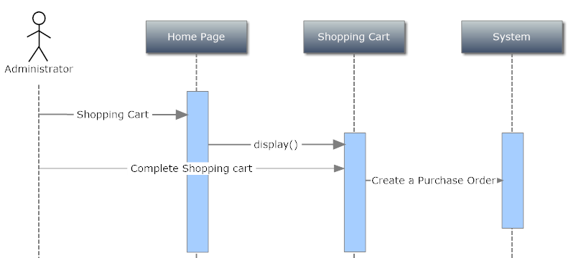

* + 1. **Update status of Shopping Cart:**

|  |  |  |
| --- | --- | --- |
| **Author** | Nguyen Ngoc Chan | |
| **Use Case Name** | Update status Shopping Cart | |
| **Actors** | Administrator, Sale Person | |
| **Description** | Update status is deliver status | |
| **Requirements** |  | |
| **Pre-conditions** |  | |
| **Post-conditions** | Success: Orders status is delivered | |
| **Basic flow** | Actor Actions:  1. Actor clicks ‘Purchase List’ link in Admin Home page | System Responses:   1. System redirects to PurchaseList page and displays Order List :   - Search for Order for to be set.  - Click Deliver. |
| **Alternative flow** |  |  |
| **Exception** |  |  |

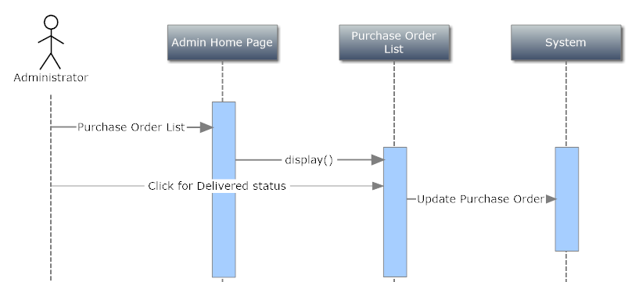

* + 1. **Cancel Orders:**

|  |  |  |
| --- | --- | --- |
| **Author** | Nguyen Ngoc Chan | |
| **Use Case Name** | Cancel Orders | |
| **Actors** | Administrator, Sale Person | |
| **Description** | Sale Person or Administrator add new product. | |
| **Requirements** | Admin or Sale person provide Product Infomation | |
| **Pre-conditions** |  | |
| **Post-conditions** | Success: Create new Product for website  Fail: Refill information | |
| **Basic flow** | Actor Actions:  1. From ‘Purchase Order List’ page, actor clicks on to the ‘Order Name’ hyperlink which wants to cancel. | System Responses:  2. System redirects to Purchase Order Detail page and displays Order Detail with the following control:  -Order Items.  3. System response and show message ‘the order has been cancled’. |
| **Alternative flow** |  |  |
| **Exception** |  | . |



1. Table Definition:

|  |  |  |  |  |  |  |
| --- | --- | --- | --- | --- | --- | --- |
| Key | Field Name | Data Type | Allow Null | Default Value | Table-Field-Ref | Description |
| PK | AccountId | Int | No |  |  | Primary key of Account table |
|  | Email | Varchar(100) | No |  |  | Email of User |
|  | Password | Varchar(200) | No |  |  | Password of User |
|  | ImageLink | Varchar(400) | No |  |  | Avatar Profile of User |
|  | FirstName | Varchar(50) | Yes |  |  | User First Name |
|  | LastName | Varchar(40) | Yes |  |  | User Last Name |
|  | Phone | Varchar(20) | Yes |  |  | User Phone |
|  | Address | Varchar(200) | Yes |  |  | User Address |
|  | Gender | Varchar(1) | Yes |  |  | User Gender |
|  | DateOfBirth | Datetime | Yes |  |  | User Birthday |
|  | ModifiedDate | Datetime2(7) | No | (SYSDATETIME()) |  | User Register Day |
|  | isAvailable | Bit | No | 1 |  | Account is Ban or not |

## Account:

## Constraint

|  |  |  |
| --- | --- | --- |
| **Name** | **FIELD** | **TYPE** |
| UC_ACCOUNT_EMAIL | Email | Unique, Non-Clustered |

## AccountRole:

|  |  |  |  |  |  |  |
| --- | --- | --- | --- | --- | --- | --- |
| Key | Field Name | Data Type | Allow Null | Default Value | Table-Field-Ref | Description |
|  | AccountId | int | No |  | Account | Id of Account |
|  | Role | Varchar(20) | No |  |  | Role of Account |

## Constraint:

|  |  |  |
| --- | --- | --- |
| **Name** | **FIELD** | **TYPE** |
| UC_ACCOUNTID_ROLE | AccountId,Role | Unique, Non-Clustered |

## Category:

|  |  |  |  |  |  |  |
| --- | --- | --- | --- | --- | --- | --- |
| Key | Field Name | Data Type | Allow Null | Default Value | Table-Field-Ref | Description |
| PK | CategoryId | Int | No |  |  | Id and Primary Key |
|  | Name | Varchar(100) | No |  |  | Name of Category |

## SubCategory:

|  |  |  |  |  |  |  |
| --- | --- | --- | --- | --- | --- | --- |
| Key | Field Name | Data Type | Allow Null | Default Value | Table-Field-Ref | Description |
| PK | SubCategoryId | Int | No |  |  | SubCategory ID |
| FK | CategoryId | Int | No |  | Category | Foreign key with CategoryId |
|  | Name | Varchar(100) | No |  |  | Name of SubCategory |

## Product:

|  |  |  |  |  |  |  |
| --- | --- | --- | --- | --- | --- | --- |
| Key | Field Name | Data Type | Allow Null | Default Value | Table-Field-Ref | Description |
| PK | ProductId | Int | No |  |  | Id of Product |
| FK | SubCategoryId | Int | No |  | SubCategory | Foreign key to SubCategory |
|  | Name | Varchar(100) | No |  |  | Name of Product |
|  | UnitPrice | Decimal(19,4) | No |  |  | Price per Unit |
|  | Like | Int | No | 0 |  | Amount of Like |
|  | Gender | Int | No | 0 |  | Clothes Types |
|  | Description | Varchar(MAX) | Yes |  |  | Description of Product |
|  | Avaliable | Bit | No | 0 |  | For Sale or Not |

## Constraint:

|  |  |  |
| --- | --- | --- |
| **Name** | **FIELD** | **TYPE** |
| UC_Product_Name | Name | Unique, Non-Clustered |

## PriceHistory:

|  |  |  |  |  |  |  |
| --- | --- | --- | --- | --- | --- | --- |
| Key | Field Name | Data Type | Allow Null | Default Value | Table-Field-Ref | Description |
| PK | PriceHistoryId | BigInt | No |  |  | Primary Key |
| FK | ProductId | Int | No |  | Product | Foreign Key to Product |
|  | Cost | Decimal(19,4) | No |  |  | Cost of Product |
|  | UnitPrice | Decimal(19,4) | No |  |  | Price of Product |
|  | CreatedDate | Datetime | No | (GETDATE()) |  | The Input date of new Price |

## Image:

|  |  |  |  |  |  |  |
| --- | --- | --- | --- | --- | --- | --- |
| Key | Field Name | Data Type | Allow Null | Default Value | Table-Field-Ref | Description |
| PK | ImageId | Int | No |  |  | Id of Image |
| FK | ProductId | Int | No |  | Product | Foreign key to Product |
|  | ImagePath | Varchar(400) | No |  |  | Image Path in server folder |
|  | DisplayOrder | Int | No |  |  | Order Displaying |

## FeedBack:

|  |  |  |  |  |  |  |
| --- | --- | --- | --- | --- | --- | --- |
| Key | Field Name | Data Type | Allow Null | Default Value | Table-Field-Ref | Description |
| PK | FeedBackId | Int | No |  |  | Id of Feedback |
| FK | AccountId | Int | No |  | Account | Account Id |
|  | Title | Varchar(400) | No |  |  | Title of FeedBack |
|  | Description | Int | No |  |  | Content of FeedBack |
|  | CreatedDate | Datetime2(7) | No |  |  | Date Send feedback |
|  | Status | Int | No |  |  | Is read or Revive by Admin |

## Comment:

|  |  |  |  |  |  |  |
| --- | --- | --- | --- | --- | --- | --- |
| Key | Field Name | Data Type | Allow Null | Default Value | Table-Field-Ref | Description |
| PK | CommentId | Int | No |  |  | Id of Comment |
| FK | ProductId | Int | No |  | Product | Foreign key to Product |
| FK | AccountId | Varchar(400) | No |  | Account | Foreign key to Account |
|  | Like | Int | No | 0 |  | Comment Like amount |
|  | Comments | Varchar(8000) | No |  |  | Content of Comment |
|  | ModifiedDate | Datetime2(7) | No | (SYSDATETIME()) |  | Date of Comment is Editted |
|  | CreatedDate | Datetime2(7) | No | (SYSDATETIME()) |  | DateTime of Comment is Created |

## PurchaseOrder:

|  |  |  |  |  |  |  |
| --- | --- | --- | --- | --- | --- | --- |
| Key | Field Name | Data Type | Allow Null | Default Value | Table-Field-Ref | Description |
| PK | PurchaseOrderId | Int | No |  |  | Id of Purchase Order |
| FK | AccountId | Int | Yes |  | Account | Foreign to Account |
|  | SubTotal | decimal(19,4) | No |  |  | Total money of Order |
|  | Address | varchar(MAX) | No |  |  | Address of Customer |
|  | Phone | varchar(MAX) | No |  |  | Phone of Phone |
|  | Status | bit | No |  |  | Is delivered ? |
|  | CreatedDate | datetime2(7) | No | (SYSDATETIME()) |  | Created Date |
|  | Name | varchar(MAX) | No |  |  | Customer Name |

## PurchaseOrderDetail:

|  |  |  |  |  |  |  |
| --- | --- | --- | --- | --- | --- | --- |
| Key | Field Name | Data Type | Allow Null | Default Value | Table-Field-Ref | Description |
| PK | PurchaseOrderDetailId | BigInt | No |  |  | Primary Key |
| FK | PurchaseOrderId | Int | No |  | PurchaseOrder | Foreign key to Purchase Order |
| FK | ProductId | Int | No |  | Product | Foreign key to Product |
|  | Quantity | Int | No |  |  | Order Quantity |
|  | Cost | Decimal(19,4) | No |  |  | Product Current Cost |
|  | UnitPrice | Decimal(19,4) | No |  |  | Product Current Price |
|  | Subtotal | Decimal(19,4) | No |  |  | Total of PurchaseOrder Item (Quantity * UnitPrice) |

1. Entity Description:

## Account:

## AccountRole:

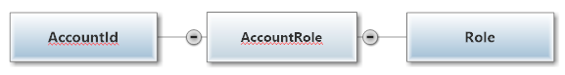

## Comment:

## Feedback:

## Product:

## PriceHistory:

## Image:

## Category:

## SubCategory:

## PurchaseOrder:

## PurchaseOrderDetail:

* 1. Tables Relationship Diagram:

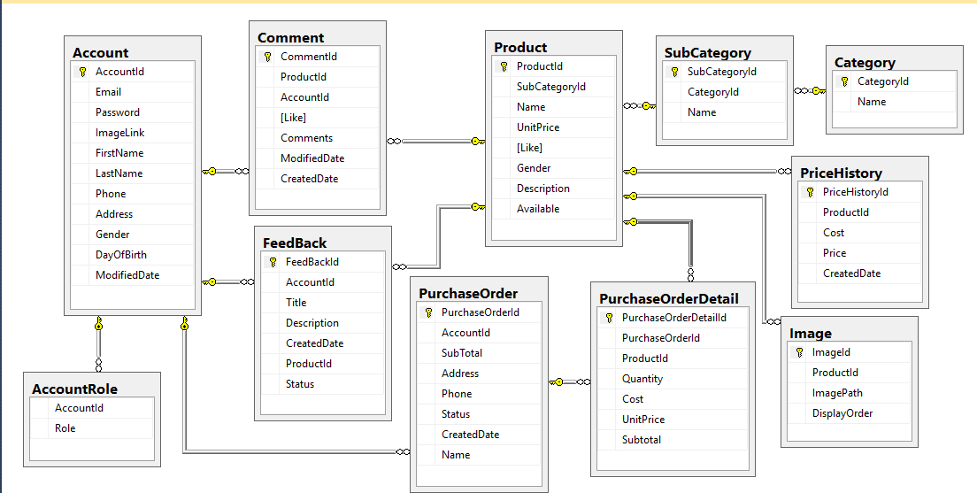

## Task Sheet 2

|  |  |  |  |  |  |
| --- | --- | --- | --- | --- | --- |
| **Project Ref. No.** | | **Project Name:**  **Unify Fashion Shop** | **Date of Preparation of Activity Plan** | | |
| No. | Task | Description | Start  Date | Complete  Date | Team member |
| 01 | **Review 2** | User Case and Sequence Diagram | **30 / 11 / 2015** | **10 / 12 / 2015** | All Team Member |
| 02 | Entity Definition |
| 03 | Tables Relationship Diagram |

**Signature of Team leader** **Signature of Instructor**

**REVIEW 3**

1. 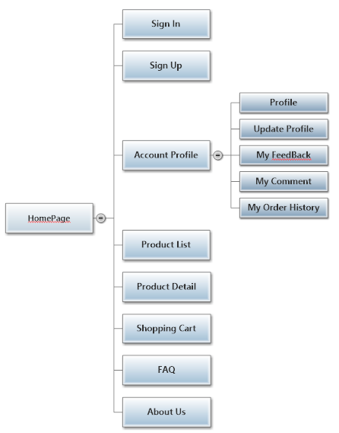**Client Site Map:**
2. 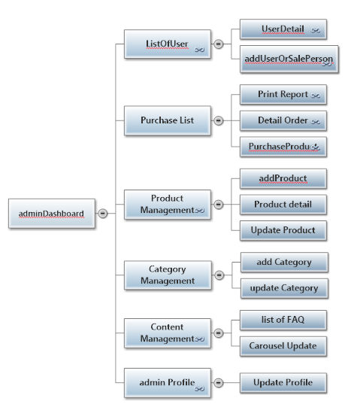**Admin Site Map:**
3. 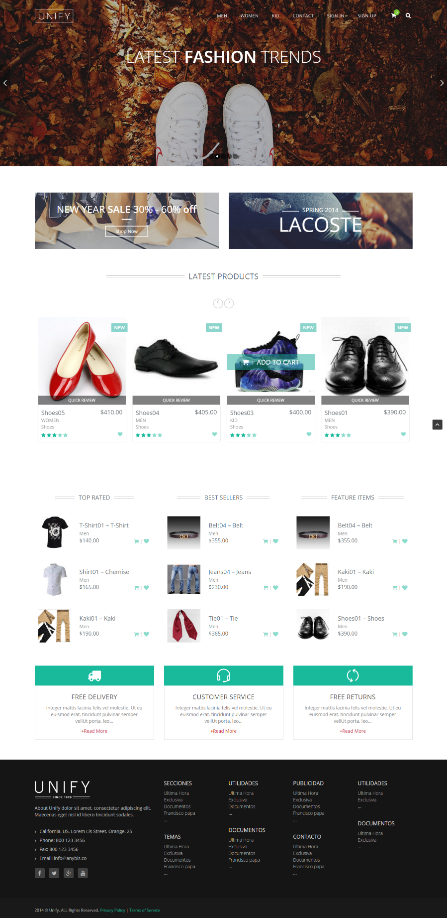**MainPages:**
4. 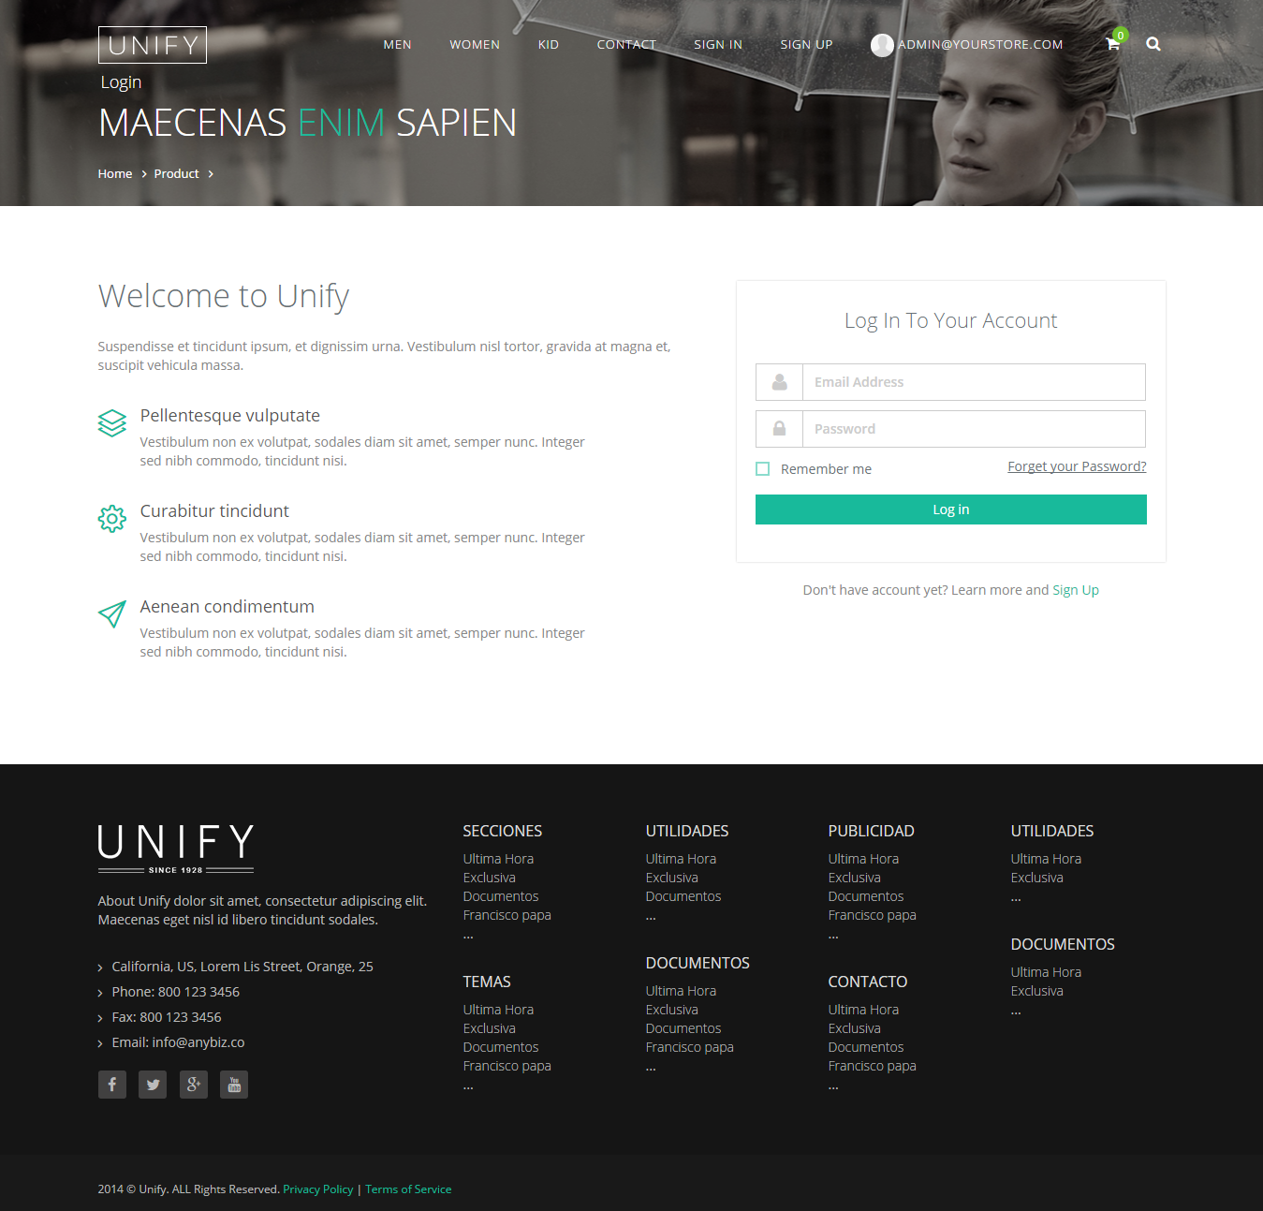**Login Page:**
5. 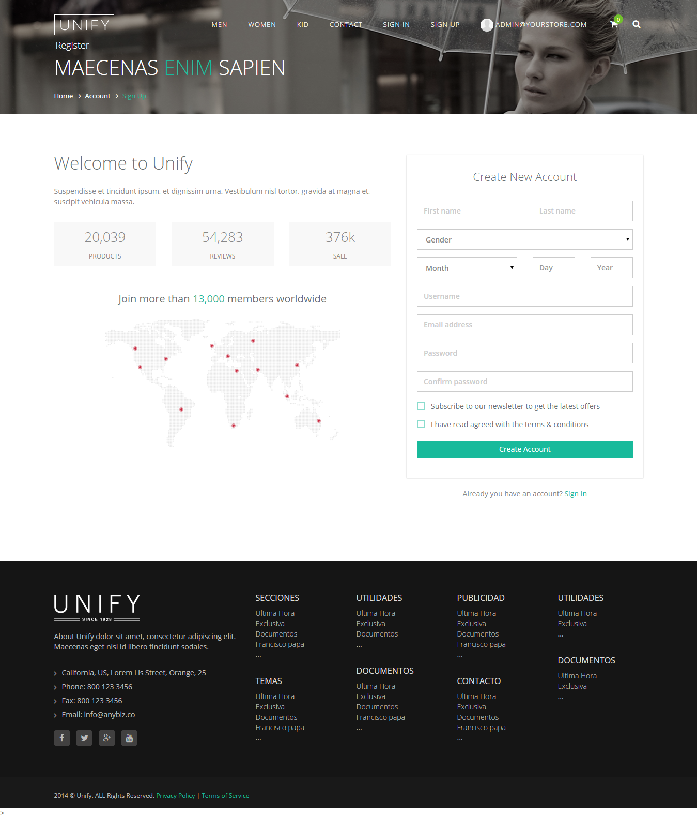**Sign Up:**
6. **Shopping Cart:**

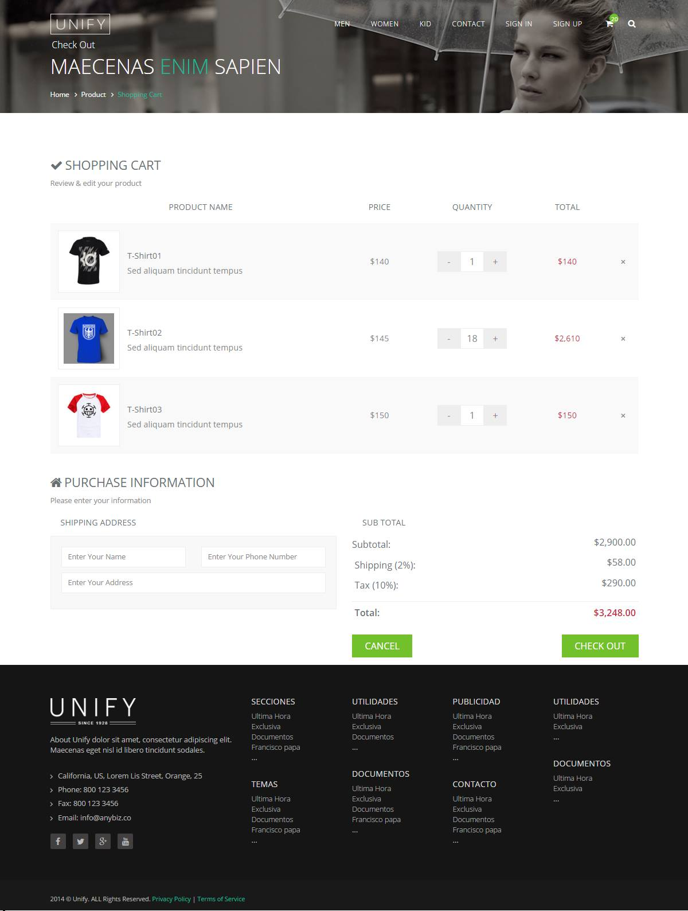

1. 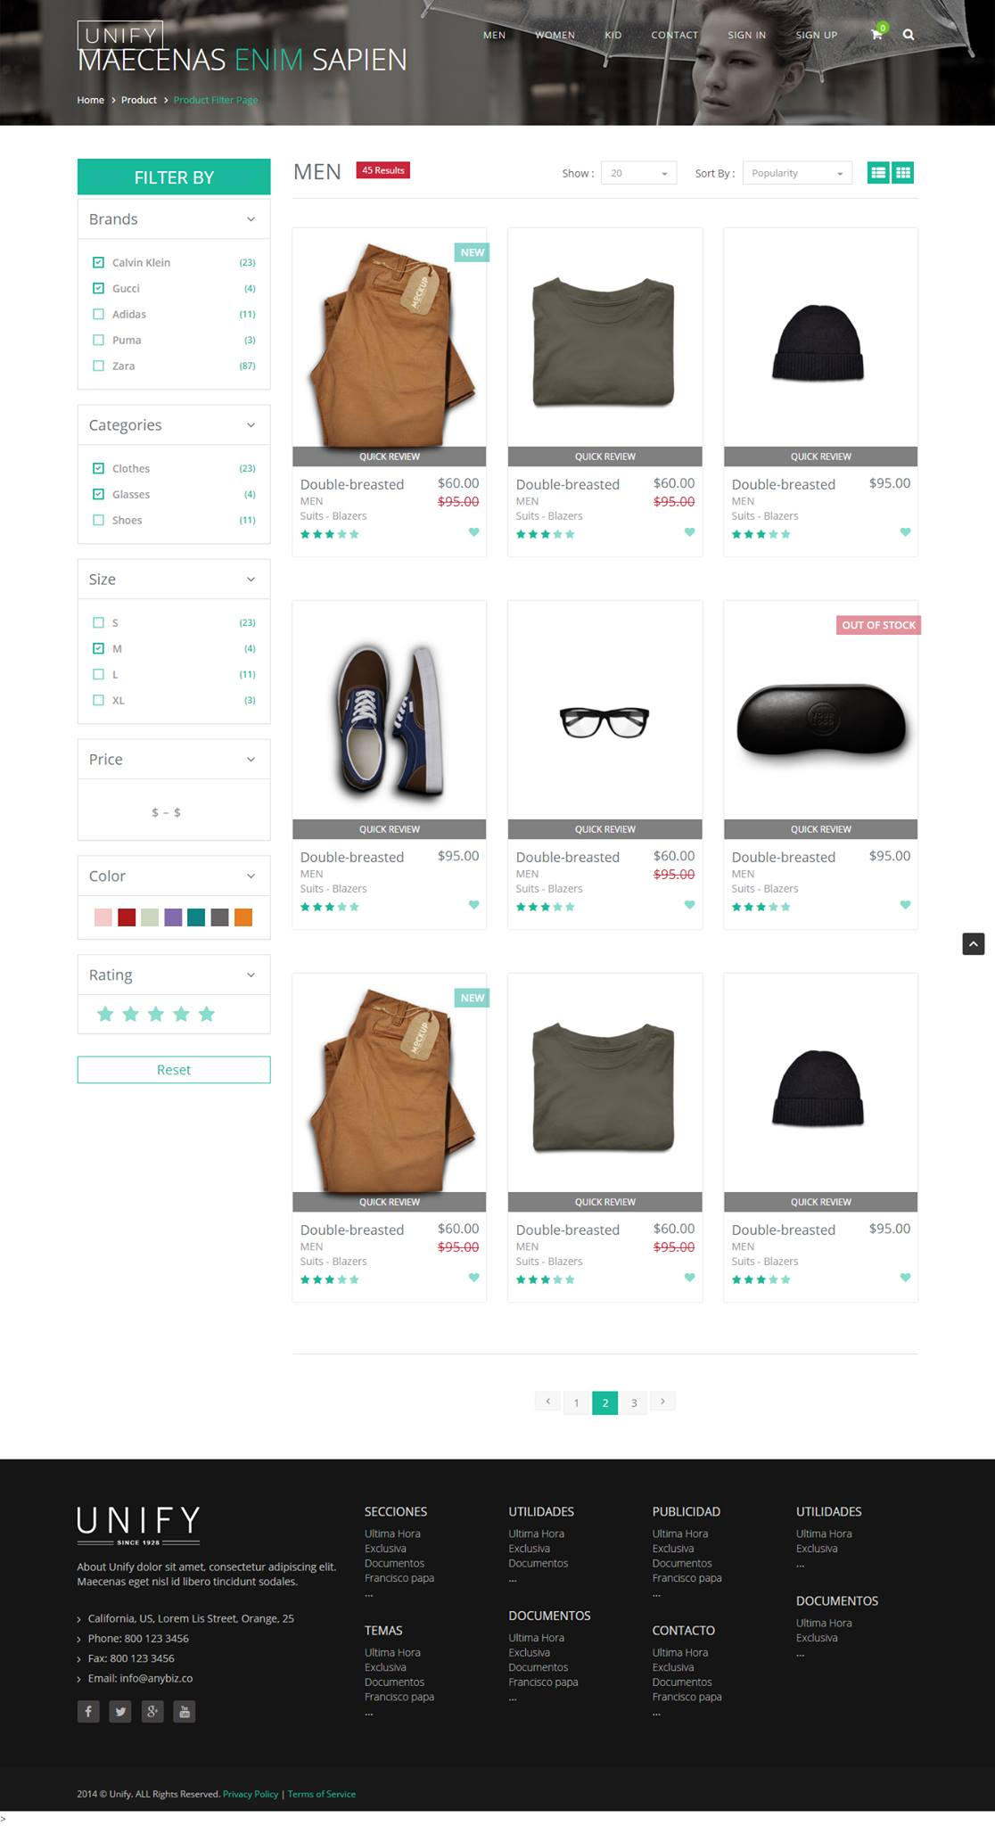**ProductList:**
2. 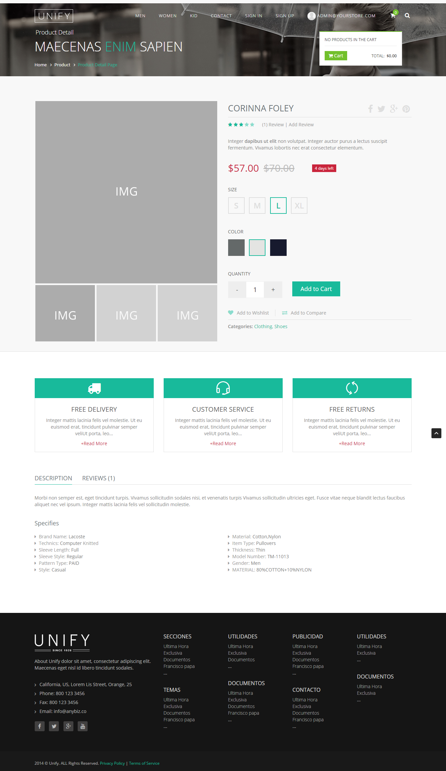**Product Detail:**
3. **Admin Dashboard:**

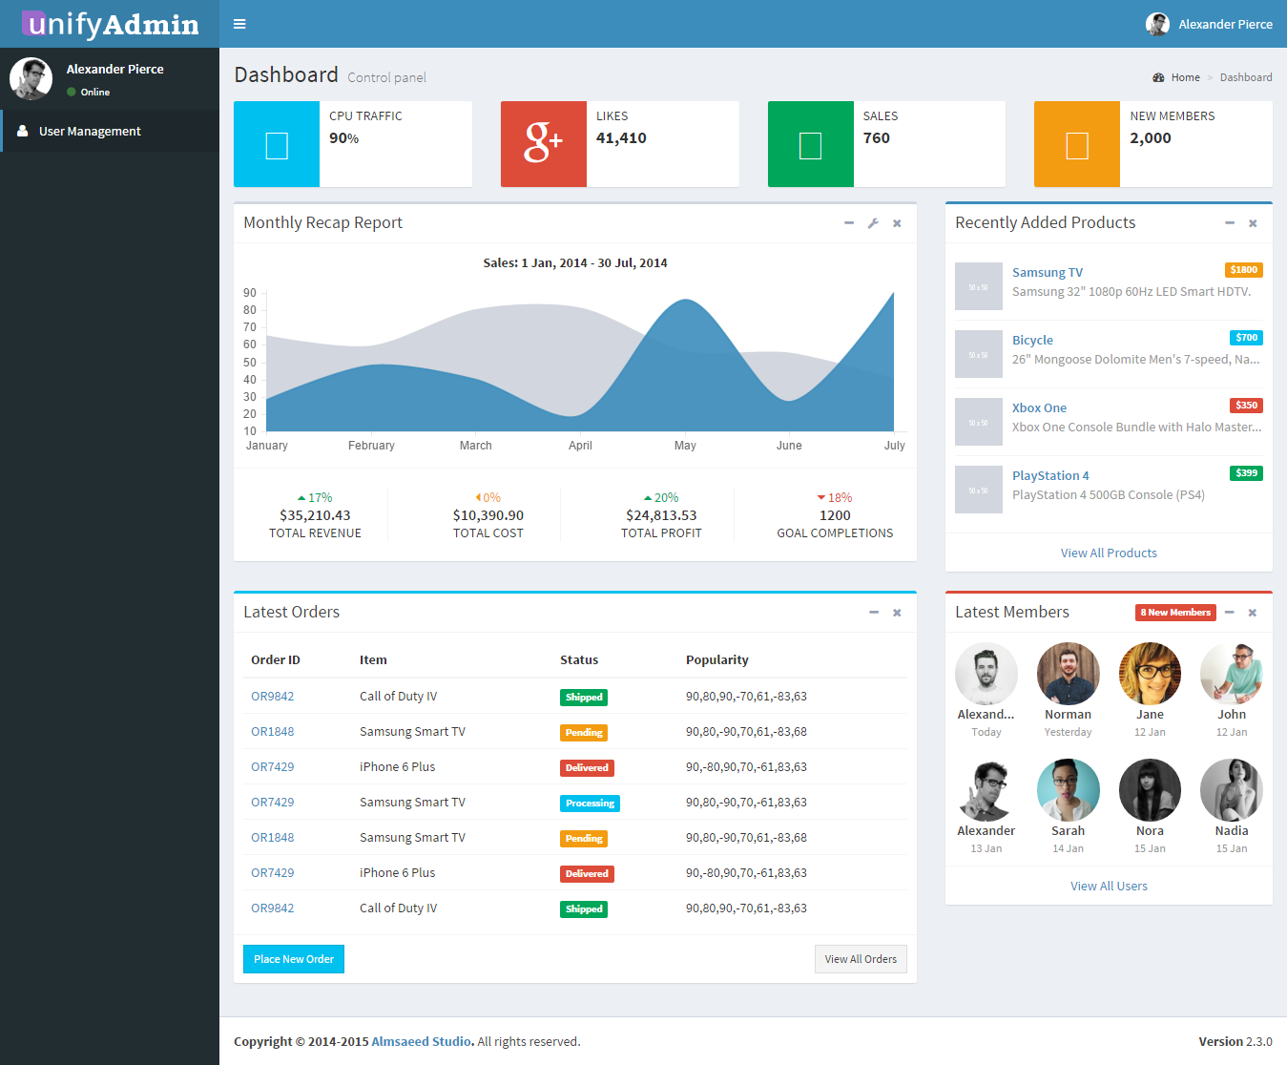

1. **Admin User List:**

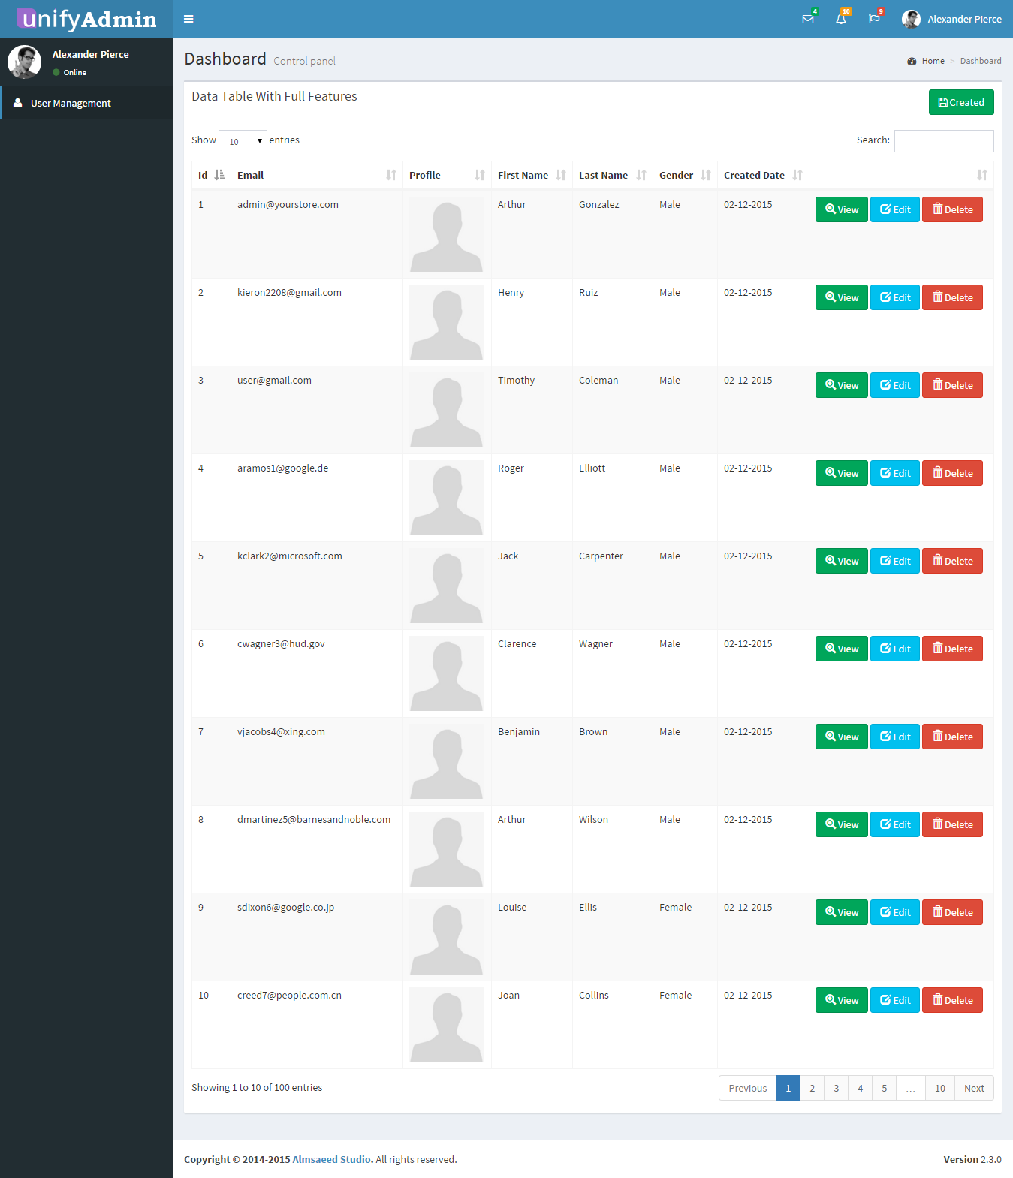

1. 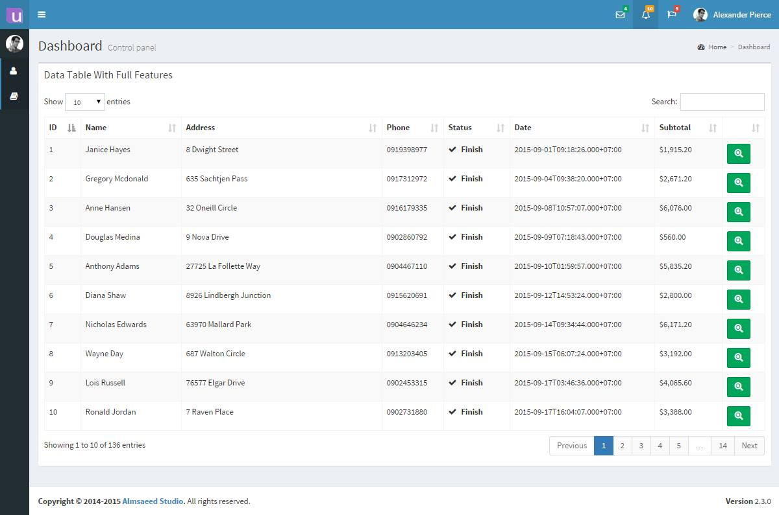**Admin Order Management:**
2. 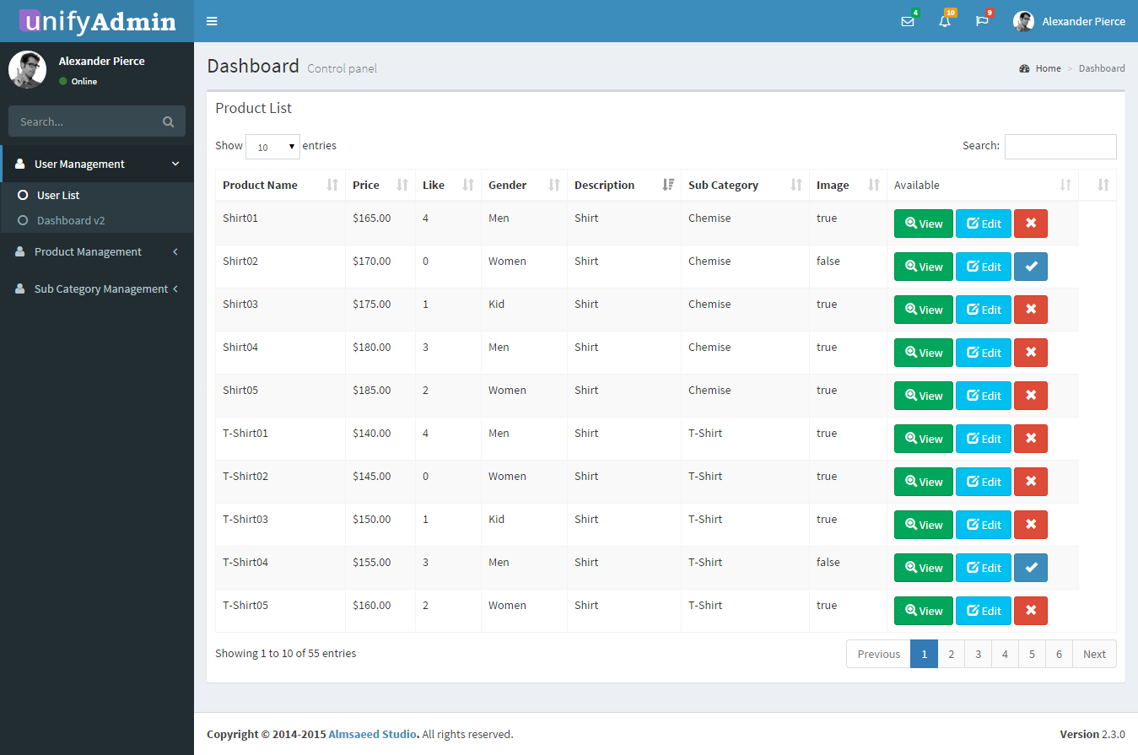 **Admin Product List:**
3. **Admin Add Product**

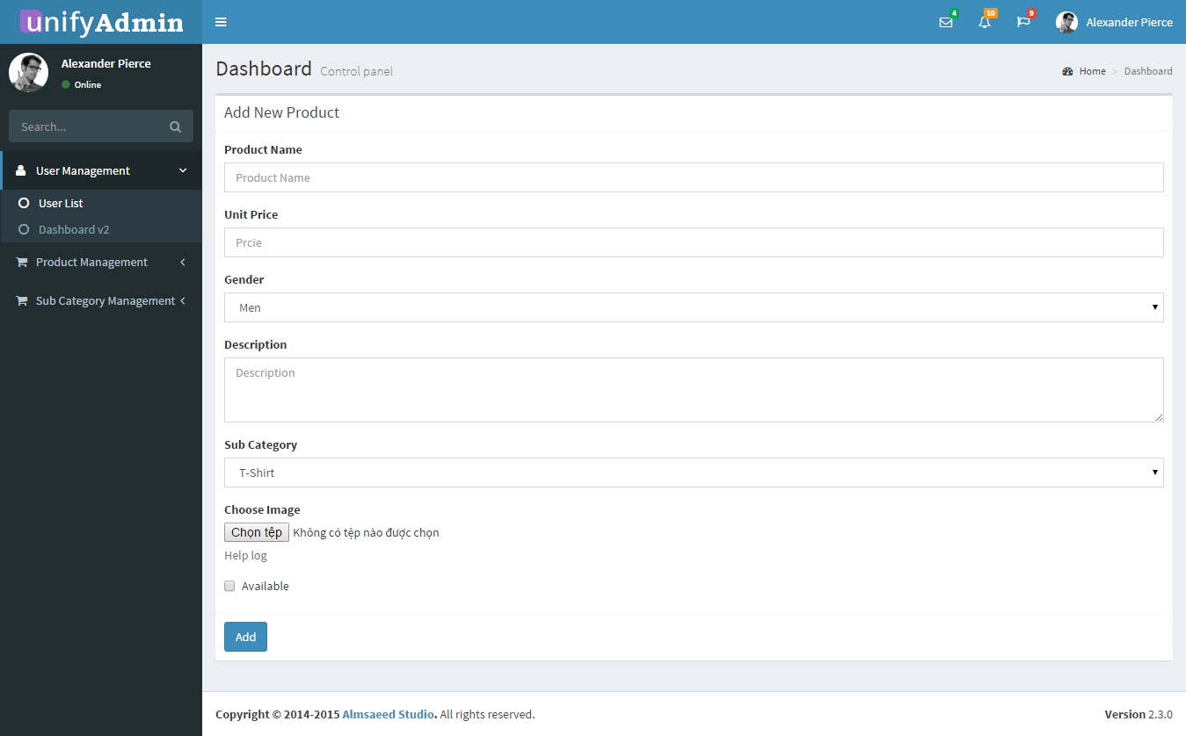

1. 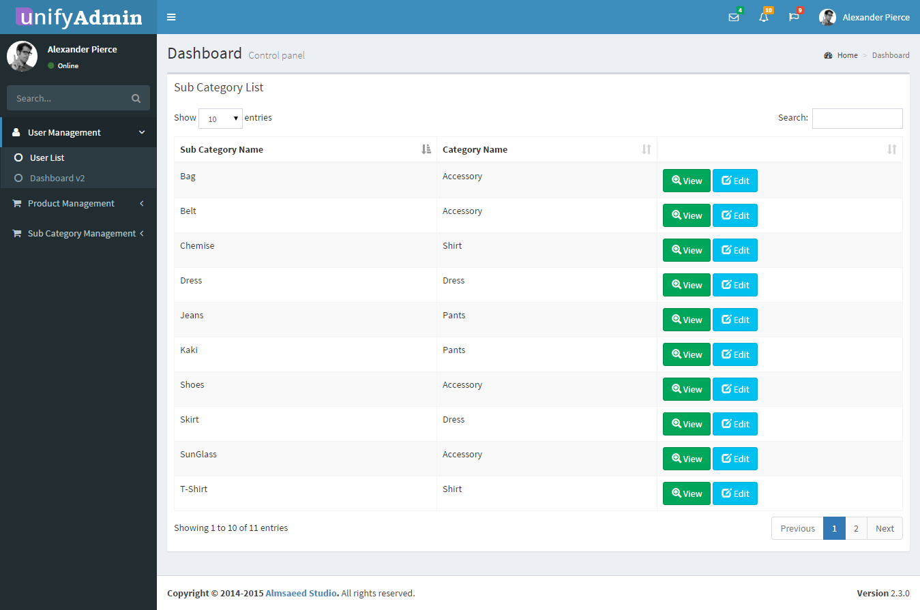**Admin Category manager:**
2. 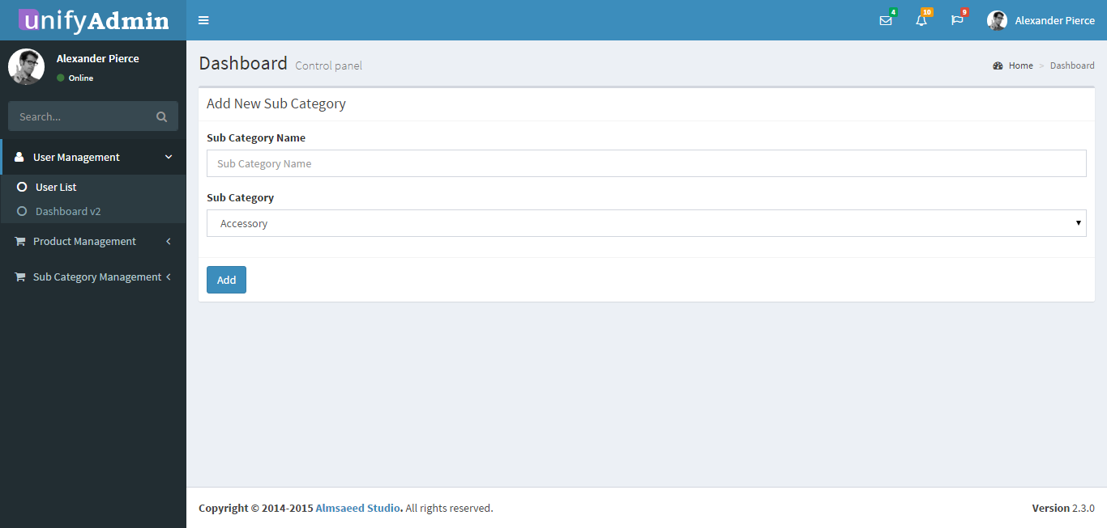**Admin Add New Category:**
3. **Add Purchase Report:**

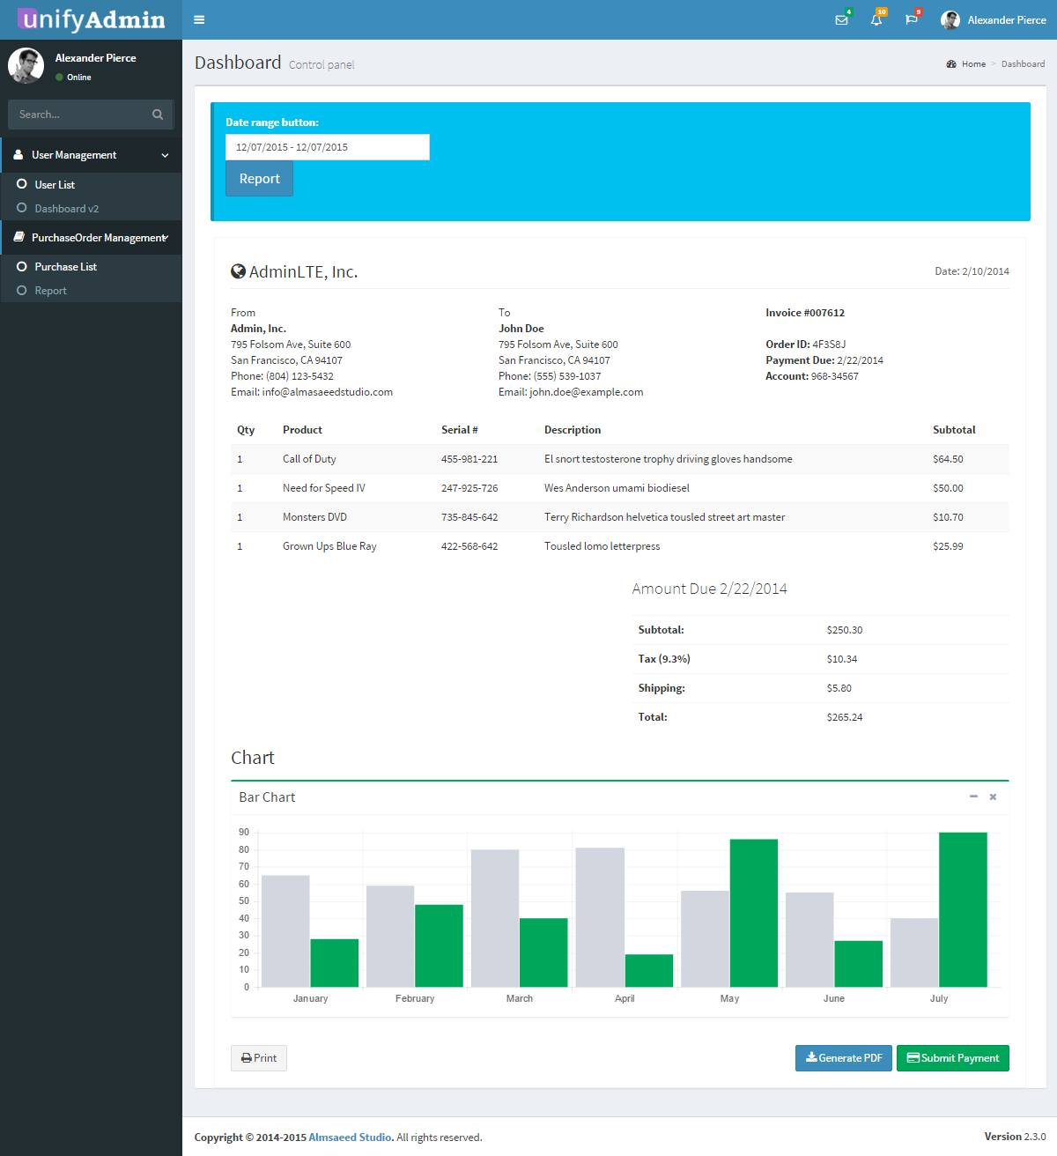

TASK SHEET

|  |  |  |  |  |  |  |  |  |
| --- | --- | --- | --- | --- | --- | --- | --- | --- |
| **Project Ref. No 1** | | **Project Title** | **Activity Plan Prepared By** | **Date of Preparation of Activity Plan** | | | | |
| **Sr. No** | **Task** | **Start Date** | **End Date** | **Actual Days** | **Member’s name** | **Status** |
| 1 | Introduction | Unify Shop | Tran Huu Quang | 11/20/2015 | 11/30/2015 | 10 | All of Member in Team | Complete |
| Existing Scenario | 11/20/2015 | 11/30/2015 |
| Customer Requirement | 11/20/2015 | 11/30/2015 |
| Functional Requirement | 11/20/2015 | 11/30/2015 |
| System Requirements | 11/20/2015 | 11/30/2015 |
| Development Software | 11/20/2015 | 11/30/2015 |
| 2 | User Login | Tran Huu Quang | 11/30/2015 | 12/10/2015 | 10 | Tran Huu Quang | Complete |
| User Register |
| User Profile |
| Admin Profile |
| View User |
| Add User |
| Admin Ban User |
| Add Sale Person |
| Report User |
| 3 | Home Page | Tran Huu Quang | 11/30/2015 | 12/10/2015 | 10 | Nguyen Thien Thuat | Complete |
| View Products (Customer) |
| Insert Product Information |
| Update Product Information |
| Report Product |
| View Detail Product |
| Add Category |
| View Category |
| Update Category |
| 24 | Create Shopping Cart | Tran Huu Quang | 11/30/2015 | 12/10/2015 | 10 | Nguyen Ngoc Chan | Complete |
| Change Status of Shopping Cart |
| View Purchase Order |
| Cancel a Order |
| Show Selling Report |
| 5 | Add Comments | Tran Huu Quang | 11/30/2015 | 12/10/2015 | 10 | Dam Trong Sang | Complete |
| Show list Comments |
| Update Comments |
| Delete Comments |
| View Feedback |
| Sent Feedback |
| Delete Feedback |
| Manager Feedback(Admin) |
| View list Feedback |
| Reply Feedback |

**Signature of Team leader** **Signature of Instructor**